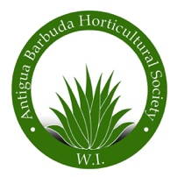**FOR THE ANTIGUA BARBUDA HORTICULTURAL SOCIETY**

**A FUND RAISER**

**COCKTAILS FOR THE RHS CHELSEA FLOWER SHOW, London, England**

**PLEASE JOIN US !**

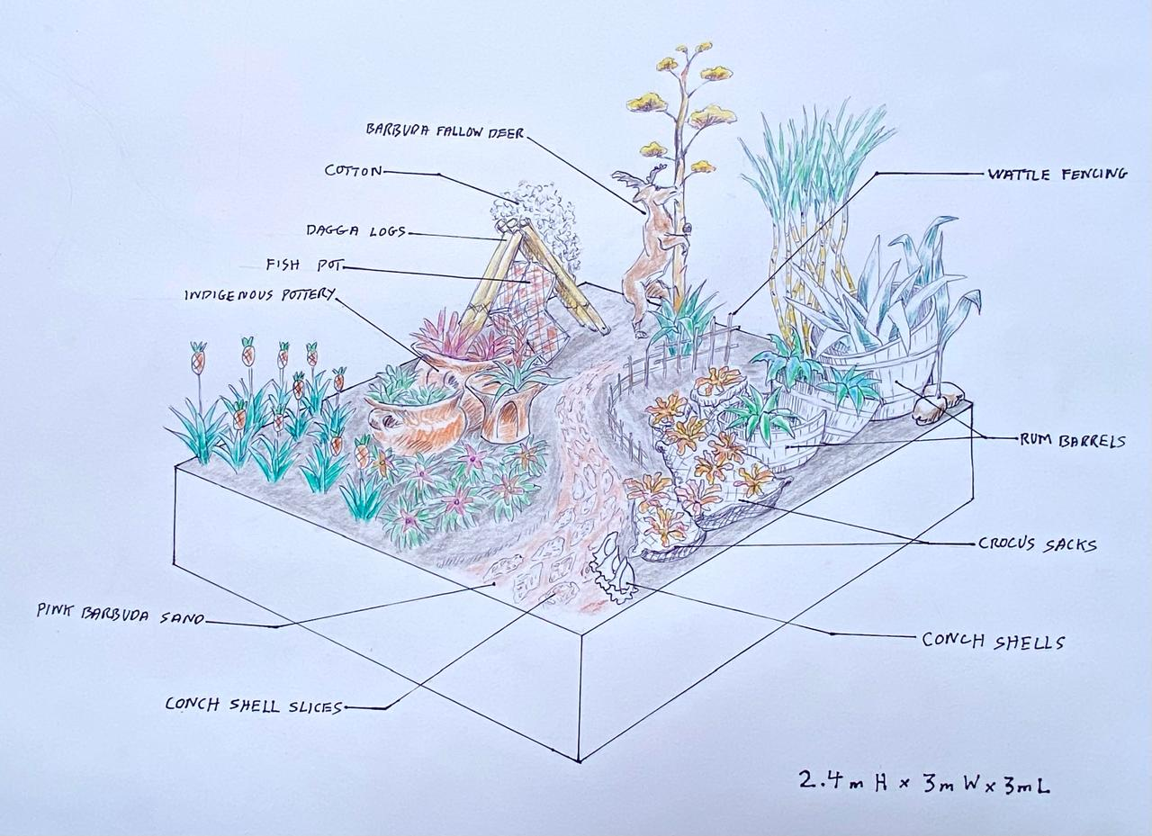**and see our display “a glimpse into the past’**

**DATE: SATURDAY APRIL 5th, 2025**

**TIME: 4.00pm to 6: 30pm**

**AT: AGAVE GARDENS**

**CONTRIBUTION: $ 100.00**

**Tickets on sale from our members and at the**

**Agave Gardens, 268 725 5507 www.antiguahorticulture.com**

**Help our team as we showcase Antigua Barbuda for the first time on the world stage, we hope to get a Medal, we are going for the Gold.**