**ABHS is pleased to offer Flower arranging classes @ Agave Gardens**

Please sign up here: classes are offered for;

**Beginners:** (would you like to arrange flowers for your home for friends using flowers from your garden then join us for our new flower arranging course for beginners where you will learn in a fun and friendly class basic flower arranging skills.)

Arrangements 101:

February 19/26/ March 4th /11th and 18th

Wednesdays for 5 weeks

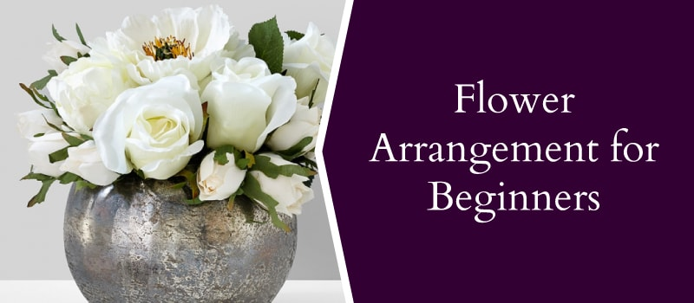

Classes are offered for intermediate

ARRANGEMENTS 102 :   
We are excited to offer the next 5 Week Intermediate

**Intermediate:**

FEBRUARY 17/24/ MARCH 2 /9 and 16

Mondays for 5 weeks

This is a great refresher course for the Intermediate or the take it to the next level and learn new techniques, work with a variety of material, styles.

Floral arrangements Intermediate

