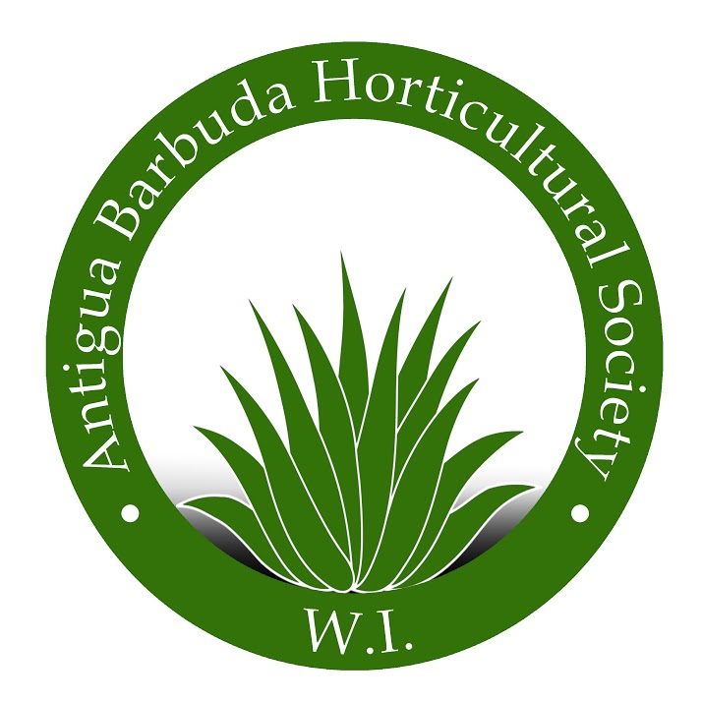Antigua Barbuda Horticultural Society

P.O. Box W212, St. John’s @Agave Gardens Friars Hill Road, St. John’s, Antigua 268 725 5507 www.antiguahorticulture.com

**MEMBERSHIP APPLICATION/RENEWAL**

|  |  |  |  |
| --- | --- | --- | --- |
| **Amount\*** | | 50.00 Annual General Membership  $100.00 Family Membership  $250.00 Friend of the garden Membership Help us purchase plants for the gardens and continue our development  $500.00 Help us maintain and purchase seating, expand our school outreach and teaching workshops  Other- Sponsor Membership  $  .00 Please see our donor page | |
| **E-mail* Telephone** | | Email is required. Please enter a valid email. | |
| **Address** | | Area of interest: | |
| **Gift Membership Note** | | I have a special message for ABHS to send to the gift recipient | |
| **Gift Membership Recipient** | | Please enter the name(s), address and phone of the gift recipient. If you think he/she would like to receive email from the ABHS, please include their email address. | |
|  |  | |
| **Phone\*** | Ext.  Phone number is required. Please enter a valid phone number. | |
| **Subscribe Here!** | Yes! Please sign me up to receive the ABHS quarterly e-newsletter. | |

**About Us: We meet the first Thursday in the month November to May, a general meeting four times annually, and an executive meeting twice annually.**

* Executive Board
* President- Mrs. Barbara Japal -268 725 5507
* Development - Mr. Patrick Ryan 464 0619
* Secretary - Mrs. Generis Taylor Hodge 268 764 5620
* Treasurer –
* -Asst. Treasurer- Mrs. Yvonne Martin- 268 561 0982
* Events- Mrs Chrsitie Martin 268 561 5255
* Under of the Patronage Of His Excellency Governor General, Sir Rodney Williams

We ask that you mail your check to **Antigua Horticultural Society** and indicate

Interests and if you can volunteer.

P.O. Box W212, St. Johns, Antigua WI.

RECEIVED:

MEMBERSHIP CARD ISSUED: Date: