Agave Gardens,
2019 Spring Summer Newsletter

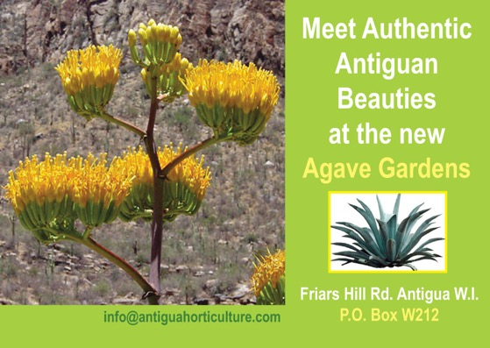

WELCOME FRIENDS AND MEMBERS to our 11th Newsletter, we are teaching what we know and sharing what we grow! Please join us.
ABHS Agave Gardens
Friars Hill Road
St. John’s
Antigua
268 725 5507

Agave Gardens, What’s New!

Flower and Garden show 2019 was held on Saturday April 13th 2019
Under the Patronage of His Excellency, The Governor General Sir Rodney Williams.

In spite of the fact that Easter was later this year (the show is hosted annually on the Saturday prior to Easter), and we have desruptive road works at our entrance on Friars Hill Road which makes it difficult to park, our attendance was very good, with over 450 in attendance and raising an impressive $14,000.00 with the Hort Café
generous donations, and commitee contributing the most.
We are also pleased to say we had over 35 of our market partners who are varied and the quality and diversity of the products continues to grow and improve.

Improvements to the garden continues as well as a series of new gardens, members are urged to plant and cultivate.
Sites from the 2019 Flower and Garden show.



His Excellency Sir Rodney Williams

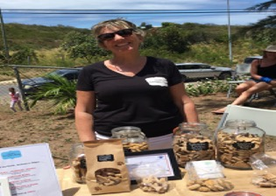

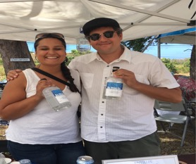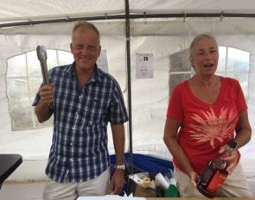

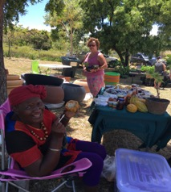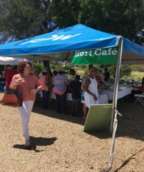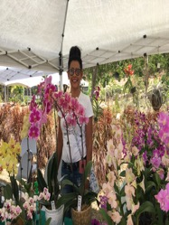
‘Our market partners’. Best in show

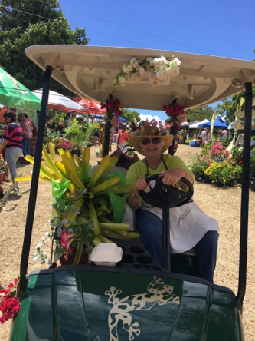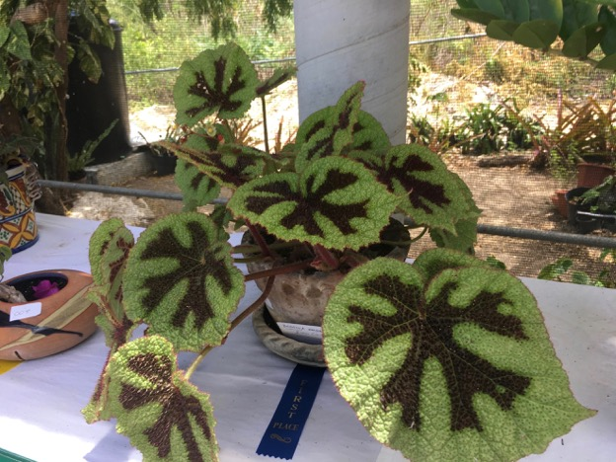
Agnes and her golf cart is one of the highlights of the show she offers a great way to see the show and transport your plants!

Agave Gardens, Youth
We welcome the youth to our gardens, all schools starting at age five.
This year we had summer campers with the introduction to our wild medicinal garden, our national flower the Agave and a walk touch and learn what grows
We are embarking on supplying seeds and seedlings to
schools.

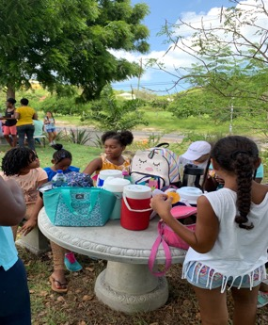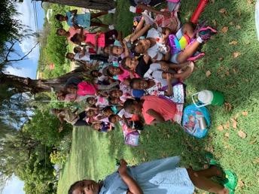

Agave Gardens, Shade House and shop
We have replaced all of our shelving with concrete tables, and have used this space to house many cuttings of plants from our gardens for sale, we have a developing section of wild medicinal plants. And the shade house is a wonderful spot to learn and planr
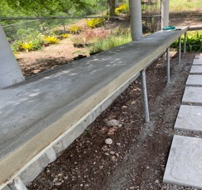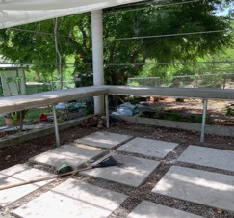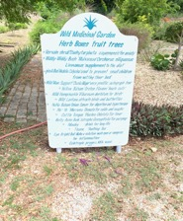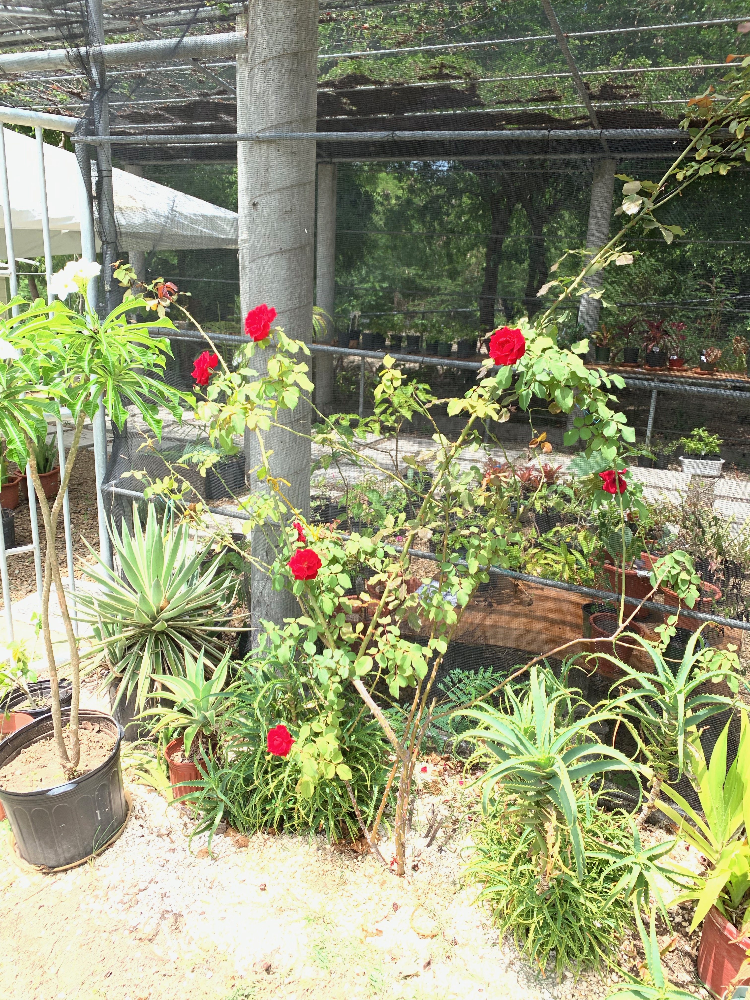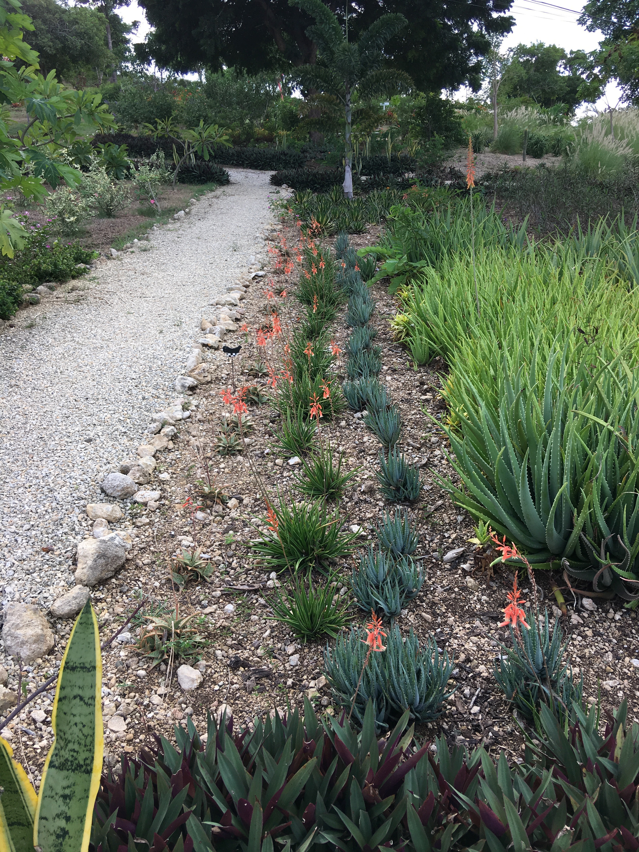

Agave Gardens, 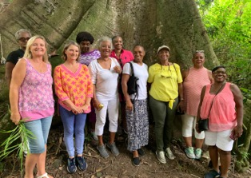Commmunity. 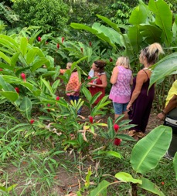
Open gardens – we schedule as many garden visits to create a sense of interest in a variety of gardens, learn from the design and garden practices and get motivated to plant and grow.
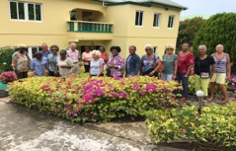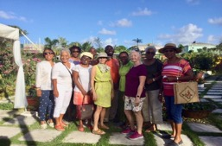
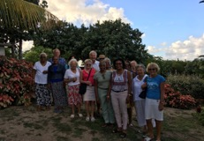

To become a "Friend”
If you live overseas but would like to be active with our development, please become a Friend.
We suggest range of annual donation

Thank you to our ongoing supporting friend Mrs. Daphne Davis our first ‘friend’

Subscription fees as follows: Donate on line info@antiguahorticulture.com
or send checks to Antigua Horticultural Society. P.O. Box W212, St. John’s
Antigua WI

Corporate: $1000.00
Family: 350.00
Individual: $150 to $200.00
Child under l5: $20.00

First name. & E mail
Last Name
Address
City
State Country
www.antiguahorticulture.com, https://www.facebook.com/AntiguaHorticultureSociety
Or telephone 268 725 5507 Please join us!
Comments and information for inclusion in the next newsletter
Should be sent to info@antiguahorticulture.com

