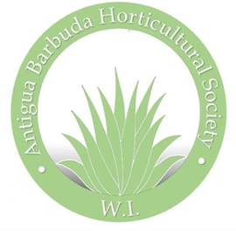Antigua Barbuda Horticultural Society 268 725 5507, www.antiguahorticulture.com

Dear Market Place: Our theme is Wild Plants

Celebrate Gardening in Antigua Barbuda, 9th annual Flower and Garden Show, 2019

Saturday April 13th from 10 am to 6 pm at the Agave Gardens, Friars Hill Road.

Plan now to Exhibit, or sponsor the show

Our Flower & Garden Show is big, exciting, entertaining, and full of opportunity! It’s the perfect place to expand your customer base.

Meet prospects and sell merchandise, introduce and demonstrate new products, generate sales, develop brand name recognition, call to take a booth today, space is limited.$ 100 per booth.

Most Cordially,

Barbara Japal

President 